AWS Glue Studio is GUI based service to create, run, and monitor extract, transform, and load (ETL) jobs in AWS Glue. It helps in visually composing data transformation workflows and run them on AWS Glue’s Apache Spark-based serverless ETL engine. AWS Glue Studio supports both tabular and semi-structured data. AWS Glue Studio also offers tools to monitor ETL workflows and validate that they are operating as intended.
In this exercise, you create an ETL job using AWS Glue Studio which reads data from the data lake data catalog, performs transformation and writes to the S3 bucket.

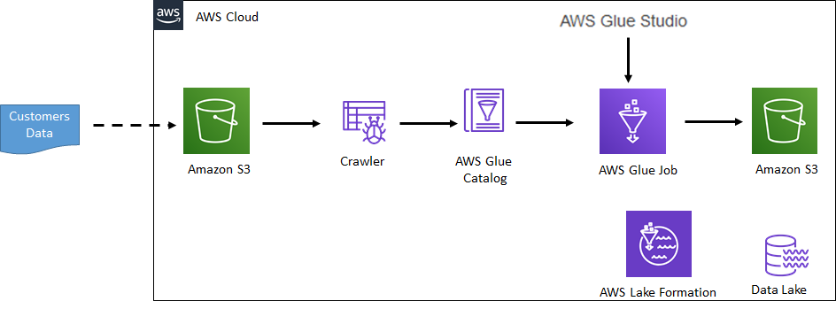

1: Pre-requisite
You need to have an AWS account with required permissions to complete the exercise. Kindly check with the instructor.

2: Data and Processing
Before you start, let’s understand the data and what data processing we configure by creating AWS Glue Job in AWS Glue Studio.
You will configure a quick and small data lake with a sample customers data. The data is stored in Amazon S3. AWS Glue and AWS Lake Formation services are used to create the data lake.
The following is the schema of the customers data:
fields: {CUSTOMERID, CUSTOMERNAME, EMAIL, CITY, COUNTRY, TERRITORY, CONTACTFIRSTNAME, CONTACTLASTNAME}
You create a Glue job in the Glue Studio which reads {CUSTOMERNAME, EMAIL} fields from the dataset and writes to a S3 bucket.

3: Create S3 Bucket
You create Amazon S3 bucket and upload data for the data lake. For this workshop, you are uploading data manually but in actual production usage the data is uploaded using data ingestion services / pipeline such as AWS Glue, Amazon Kinesis etc. Since the focus of the workshop is introduction to AWS Glue Studio, it keeps the data ingestion out of scope.
- Goto S3 Management console, use + Create bucket button to create a new bucket with name glue-customer-data. If the bucket name is not available, then use a different name which is available.
- Click on the glue-customer-data bucket to open it. Within the glue-customer-data bucket, create two folders data and output using the + Create folder button. The data folder is used to keep the data lake data while the output folder is used by the Glue Job to write processed data.
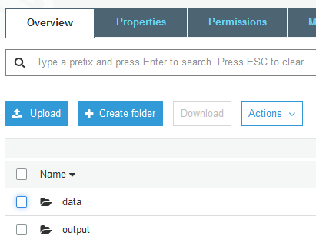
- Click on the data folder to open it. Within the data folder, create a folder customers using the + Create folder button.
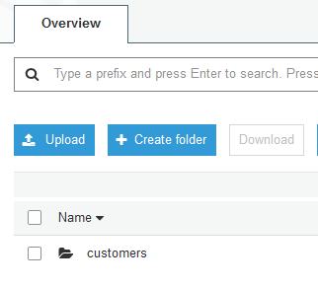
- Click to open customers folder and upload customers.csv file. Use Upload button to upload the files. The customers.csv file is available for download using the following link - customers.csv
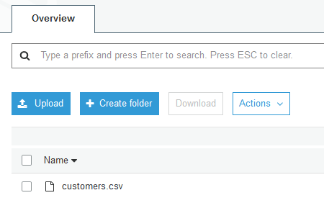
- The data is ready. Let’s start with the data lake configuration.

4: Configure Data Lake
The data is ready in Amazon S3 bucket. Let’s start the configuration of the data lake. In data lake, you create a database and configure it with Amazon S3 bucket location. A database is used to organize data catalog tables in the data lake. You will later configure crawler to automatically create the data catalog tables in the data lake.
- Open the AWS Lake Formation console. If you are using Lake Formation for the first time in the region, it will ask you to create a data lake administrator. A data lake administrator is an IAM user or IAM role that performs administrative tasks in the data lake. For the first time user, it will popup a message to add administrators. Click on the Add administrators button to create administrators for your Data Lake.
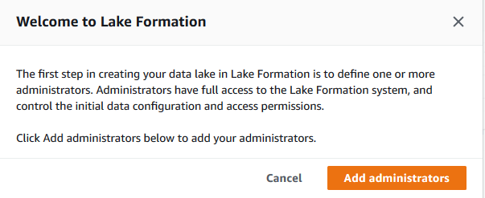
- Select your AWS logged-in IAM user from the drop down list. For the rest of handson, the user will be considered as a data lake administrator and will have full access to the data lake. Click on the Save button.
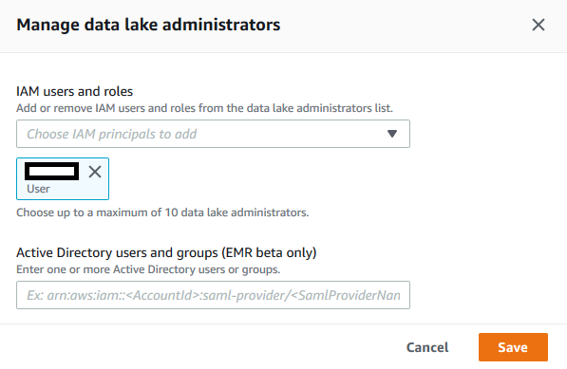
Note: if you did not get the popup then that means the data lake already has an administrator. You can check that by clicking on the “Admins and database creators” menu in the left. If you see that your logged-in IAM username is listed as the “Data lake Adminstrator” then you are ok to move to the next step. Otherwise, click on the “Grant” button to add “your AWS logged-in IAM user” as the administrator of the data lake.
- After adding the administrator, you will create the database. In the AWS Lake Formation console, click on the Databases option on the left menu and then click on Create database button.
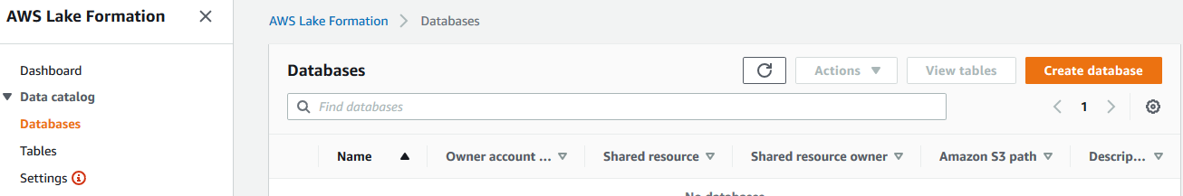
- On the next screen, select Database option and type in gluedb as the Name. In the Location box, select the S3 data lake path as s3://glue-customer-data/data. If you created the bucket with different name, then you replace glue-customer-data part with that name. Make sure you Uncheck the option - Use only IAM access control for new tables in this database. Leave rest of the options as default and click on Create database button.
- The database is added in no time. Now register the Amazon S3 bucket as your data lake storage. In the navigation pane, choose Data lake locations, and then choose Register location.
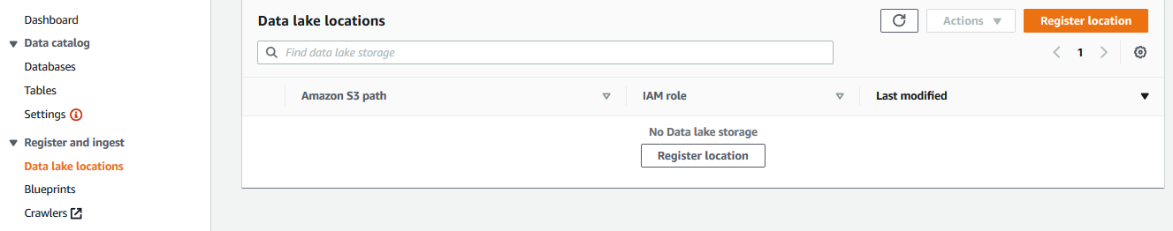
- Enter a path to the existing S3 bucket s3://glue-customer-data/data. If you created the bucket with a different name, then you replace glue-customer-data part with that name. For the IAM role, select the AWSServiceRoleForLakeFormationDataAccess role. Click Register location to save it.
- It is time to use crawler to catalog the data in the database.

5: Configure and Run Crawler
One of the fundamental principle of building the data lake is that every data in the data lake should be catalogued. The catalog is automated using crawlers in AWS Glue. The crawler uses role based authorization to create catalog in the data lake database.
Open the AWS Lake Formation console, click on the Databases option in the left. You will see gluedb database listed.
- Select the gluedb database and click on the Grant menu option under the Action dropdown menu.

- On Grant permissions screen, choose for the My account option and select <role> for the IAM users and roles field. Select only Create table and Alter permissions for the Database permissions. Then click on the Grant button. It means you are authorizing crawler role to be able to create and alter tables in the database.
- After assigning permission, time to configure and run crawler. Open the AWS Glue console. Click on the Crawlers menu on the left and then click on the Add crawler button.
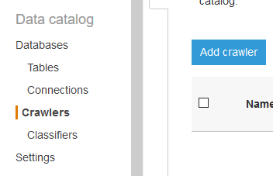
- On the next screen, enter gluecrawler as the Crawler name and click Next.
- On the next screen, select Data stores as the Crawler source type and click Next.
- On the next screen, select S3 as a data store and select Specified path in my account option. Provide the include path for the S3 bucket as s3://glue-customer-data/data/customers. If you created the bucket with a different name, then replace glue-customer-data part with that name. Click Next.
- On the next screen, you are going to crawl only one data store, so select No from the option and click Next.
- On the next screen, select Choose an existing IAM role option and then select IAM role from the dropdown list. Click Next.
- On the next screen, select Run on demand as the frequency and click Next. In actual production use, you generally schedule crawler run so that it automatically updates the catalog.
- On the next screen, select gluedb as the database. Click Next.
- On the next screen, verify all crawler information on the screen and click Finish to create the crawler.
- The crawler is created in no time. Select the crawler and click on the Run crawler button to run the crawler.
- It might take couple of minutes for the crawler to finish crawling the bucket. You would see a success message that there is one table customers created by the crawler in gluedb database.

- Go back to the AWS Lake Formation console, click on the Tables menu in the left. You can see customers table created.
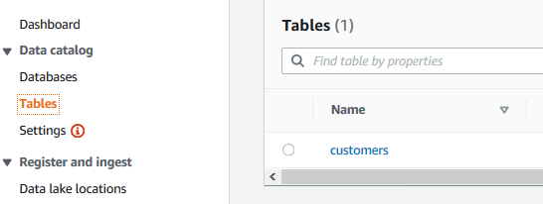
- In the next step, you write a Glue Job using AWS Glue Studio.

6: Create Job in Glue Studio
In this step, you create a job using Glue Studio which reads data from the customers table and writes only {CUSTOMERNAME, EMAIL} fields to a S3 bucket folder.
- First you grant <role> role Select access permission on the customers table because this role is used by the job you are going to create.
- Go to Lake Formation Console. Click on the Tables menu in the left. Then select customers table and click on the Grant menu option under Actions.
- On the next screen, select My account option. Select <role> as the IAM Users and roles. Choose Select for the table permission. Keep rest of the configuration to the default and click on the Grant button.
- The role now has the required access permission. Go to Glue Service console and click on the AWS Glue Studio menu in the left.
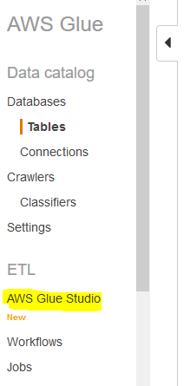
- On the next screen, click on the Create and manage jobs link.
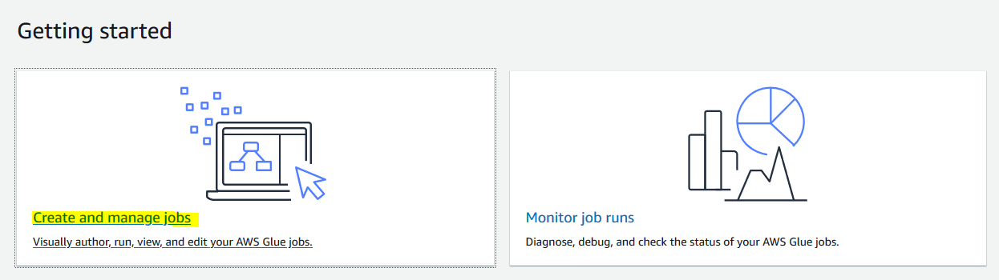
- On the next screen, select Blank graph option and click on the Create button.
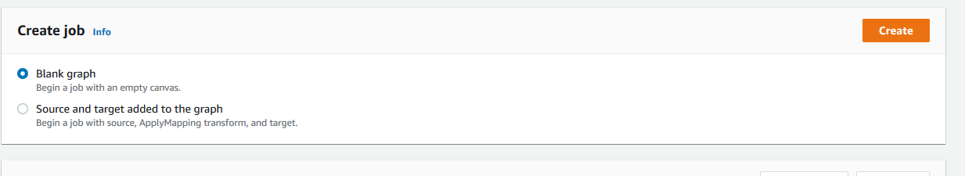
- It opens the Glue Studio editor. Click on the Job Details tab. Type in mygluejob for the name and select <role> for the IAM Role. Keep rest of the fields as the default and click on the Save button.

- The job name and role configuration is saved. Go back to the Visual tab and click on the + icon.
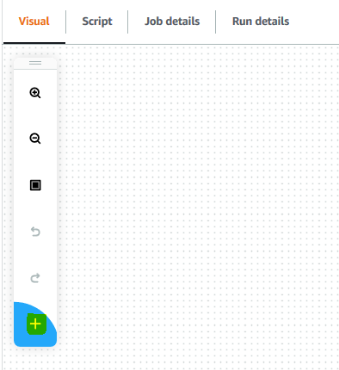
- It creates a new node in the editor. On Node properties tab, type in Read-Source for the name. Select Data source - S3 Bucket for the node type. Click on the Data source properties - S3 tab.
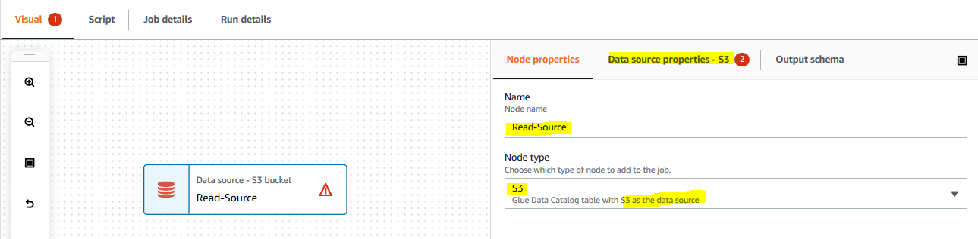
- On the Data source properties - S3 tab, select gluedb as the database, select customers for the table. You are selecting customers table in the gluedb as the source. Click on the Save button. The job is saved.
- On the Visual tab and click on the + icon to add a new node. On Node properties tab, type in Select-Data for the name. Select Transform - SelectFields for the node type. Keep the node parents field to Read-Source. Then click on the Transform tab.
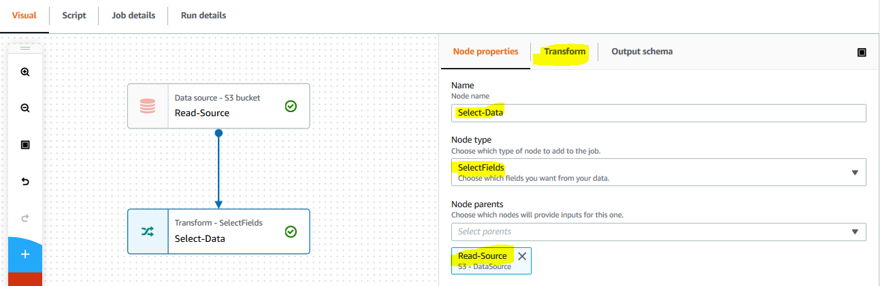
- On the Transform tab, select customername and email fields and click on the Save button. You are selecting select fields transformation and filtering down the data column to the customername and email fields. The job is saved.
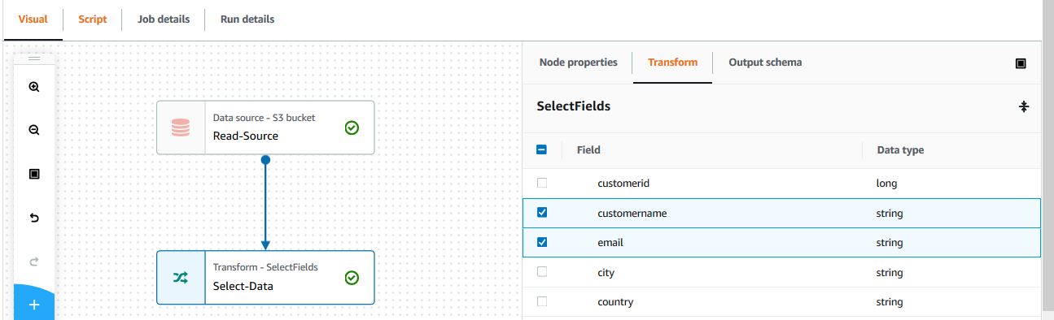
- On the Visual tab and click on the + icon to add a new node. On Node properties tab, type in Write-Data for the name. Select Data target - S3 Bucket for the node type. Keep the node parents field to Select-Data. Then click on the Data target properties - S3 tab.
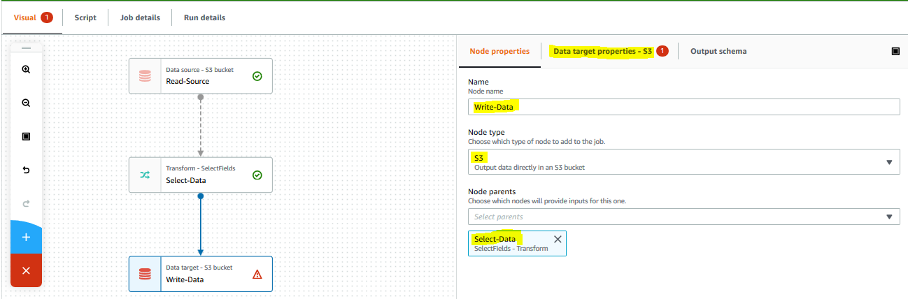
- On the Data target properties - S3 tab, keep the format for JSON. Keep compression type to None. Select s3://glue-customer-data/output/ for the S3 target location. If you created the bucket with a different name, then you replace glue-customer-data part with that name. Click on the Save button. You are asking Job to write transformed data to the S3 bucket in non-compressed JSON format. The job is saved.
- The job is ready. Click on the Run button for the job. It will start the job execution. Click on the Run Details link to check the job status.

- Wait till the status of the job changes to Succeeded.
- You can go to the output S3 bucket location to see a new file created by the Glue Job.
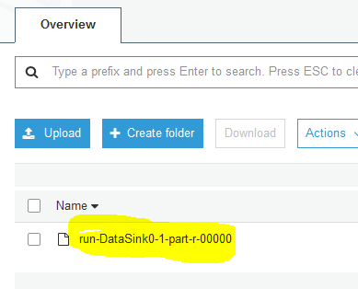
- If you download and open the file, you can see the output JSON data.
